


Royaume du Maroc
Université Sultan Moulay Slimane
Ecole Supérieure de Technologie – Béni Mellal Département Informatique et Techniques de Gestion

Spécialité : DUT en Sécurité informatique et réseaux (SIR)
Internship Report
Titled
__________________________________________________
Audit and security of a local network using pfSense and Nmap
__________________________________________________

Made by :RACHID Hajar Supervised by : JABRI Saad
Internship period: from 15/06/25 to 15/07/25

Presented and defended on 11/11/2025, before the jury composed of:

Pr. M. OURRIBBANE…………………………………………………………..Président
Pr. M. OUTANOUTE………………………………………………………….Examinateur

Internship completed at: National Fisheries Office (ONP) – Beni Mellal Academic year: 2025 – 2026

Acknowledgements

I would like to express my deepest gratitude to Mr. Kebir Chaji, Director of EST Beni Mellal, for his support and leadership throughout my academic journey.
I would also like to sincerely thank everyone who supported me during my internship and the preparation of this report.
First and foremost, I am deeply grateful to Mr. Adil Achbani, Director of ONP, for giving me the opportunity to complete my internship in such a professional and enriching environment. I also warmly thank my supervisor, Mr. Saad Jabri, for his valuable guidance, patience, and encouragement throughout the internship period.
My sincere appreciation also goes to all the teachers at EST Beni Mellal who provided me with the knowledge and skills that helped me succeed in this project.
Lastly, I want to express my heartfelt thanks to my family and friends for their continuous support, motivation, and encouragement throughout this journey.

SUMMARY
This report presents the implementation of a virtual laboratory for auditing and securing a local network. The lab was built on VirtualBox with three virtual machines: pfSense as a firewall, Kali Linux as the auditing workstation, and Ubuntu as the target server.
The work involved configuring the machines, setting up network addressing, and deploying services such as SSH and Apache. An initial Nmap scan identified open ports, after which firewall rules were applied on pfSense. A second scan confirmed their effectiveness by reducing the attack surface.
The project provided practical skills in network configuration, firewall deployment, and security auditing, and underlined the importance of firewalls in protecting information systems.

RÉSUMÉ
Ce rapport présente la mise en place d’un laboratoire virtuel destiné à l’audit et à la sécurisation d’un réseau local. Le laboratoire a été réalisé sous VirtualBox avec trois machines virtuelles : pfSense comme pare-feu, Kali Linux comme poste d’audit et Ubuntu comme serveur cible.
Le travail a consisté à configurer les machines, définir le plan d’adressage et déployer des services tels que SSH et Apache. Un premier scan Nmap a révélé des ports ouverts, puis des règles de filtrage ont été appliquées sur pfSense. Un second scan a confirmé leur efficacité en réduisant la surface d’attaque.
Ce projet m’a permis d’acquérir des compétences en configuration réseau, déploiement de pare-feu et audit de sécurité, tout en soulignant l’importance des pare-feu dans la protection des systèmes d’information.

Table of Contents

Acknowledgements 2
SUMMARY 3
RÉSUMÉ 3
Table of Contents 4
List of Figures 6
List of Tables 7
List of Abbreviations 8
General Introduction 9
Chapter 1 : 10
« Presentation of the Host Organization National Fisheries Office (ONP) » 10
1. History and Evolution : 11
2. Missions and Objectives: 12
2.1 Development of Coastal and Artisanal Fishing 12
2.2. Organization of the Marketing of Marine Fishery Products 12
3. Internal Organization (Organizational Chart): 13
4. Organizational Chart: 14
5. Conclusion : 14
Chapter 2 : 15
«Context and Objectives of the Project» 15
Introduction : 16
1. Project Context : 16
2. Problem Statement : 16
3. Project Objectives : 17
General Objective: 17
Specific Objectives: 17
4. Presentation of the Tools : 17
4.1 pfSense CE (Community Edition): 17
4.2 Kali Linux 2025.x: 18
4.3 Ubuntu Server 22.04 LTS: 18
4.4 Nmap : 18
4.5 Packet Tracer 8.x: 19
Conclusion : 19
Chapter 3: 20
«Technical Environment and Methodology» 20
Introduction : 21
1. Hardware Environment : 21
2. Software Environment : 22
2.1 pfSense CE (Community Edition): 22
2.2 Kali Linux 2025.x: 22
2.3 Ubuntu Server 22.04 LTS: 22
3. Network Topology : 22
4. Methodology : 24
Conclusion : 25
Chapter 4: 26
«Implementation of the project» 26
Introduction : 27
1. Installation of Virtual Machines : 27
➔ pfSense Installation: 27
➔ Ubuntu Server Installation: 27
➔ Kali Linux Installation: 28
➔ Network Configuration: 28
➔ Deployment of Services on Ubuntu: 28
➔ Security Audit: 29
Initial Scan (Before Firewall Rules): 29
Firewall Configuration on pfSense: 29
2. Illustrations of the Implementation : 30
Chapter 5: 37
«Results and Analysis» 37
Introduction : 38
1. Scan Results Comparison: 38
2. Interpretation of Results: 38
The comparison demonstrates that: 38
3. Discussion and Limitations: 39
4. Lessons Learned: 39
Conclusion: 39
General Conclusion 40
Web References 41

List of Figures

Figure 1: The main building of the National Office of Fisheries
Figure 2: Development of Coastal and Artisanal Fishing
Figure 3:Organization of the Marketing of Marine Fishery Products
Figure 4: ONP Organizational Structure
Figure 5: VirtualBox main dashboard showing the three created VMs
Figure 6: Network Topology Diagram created in Packet Tracer
Figure 7: pfSense WAN interface configuration
Figure 8: pfSense LAN interface configuration
Figure 9: Ubuntu terminal showing static IP address
Figure 10: Installation process of Kali Linux
Figure 11: Network adapter settings of Kali Linux
Figure 12: Ubuntu terminal showing static IP address
Figure 13: Connectivity test from Kali Linux to Ubuntu server
Figure 14: Connectivity test from Ubuntu server to pfSense
Figure 15: pfSense login page accessed from Kali browser
Figure 16:pfSense web interface welcome dashboard
Figure 18: pfSense firewall rules configuration (web GUI)

List of Tables

Table 1 — Network Devices and Roles
Table 2 — Firewall Configuration Results

List of Abbreviations

- LAN : Local Area Network
- WAN : Wide Area Network
- VM : Virtual Machine
- DHCP : Dynamic Host Configuration Protocol
- DNS : Domain Name System
- IP : Internet Protocol
- TCP : Transmission Control Protocol
- UDP : User Datagram Protocol
- SSH : Secure Shell
- HTTP : Hypertext Transfer Protocol
- HTTPS : Hypertext Transfer Protocol Secure
- NAT : Network Address Translation
- NIC : Network Interface Card
- OS : Operating System
- IDS : Intrusion Detection System
- IPS : Intrusion Prevention System
- SIEM : Security Information and Event Management
- GUI : Graphical User Interface
- CLI : Command Line Interface

General Introduction

In today’s digital era, information systems and networks play a central role in supporting organizational operations. Companies and institutions rely on computer networks to exchange data, host applications, and ensure communication between users and services. However, this growing dependence also increases exposure to cyber threats, making security a critical concern for any organization. Protecting sensitive data, ensuring service availability, and preventing unauthorized access have therefore become top priorities for IT departments.
To address these challenges, network security mechanisms such as firewalls, intrusion detection systems, and monitoring tools are deployed to reduce vulnerabilities and mitigate risks. Among these mechanisms, the firewall is considered the first line of defense, as it controls traffic entering and leaving the network.
The objective of this report is to present the work carried out during my internship at the Office National des Pêches (ONP). The project focused on the implementation of a virtual laboratory to simulate a local area network, perform a security audit using Nmap, and apply firewall rules with pfSense. By comparing the results of scans before and after the application of these rules, the project demonstrates the effectiveness of access control in reducing the attack surface of a system.
This introduction sets the foundation for the detailed presentation of the host organization, the context of the project, the methodology followed, the results obtained, and the lessons learned.

Chapter 1 :

« Presentation of the Host Organization National Fisheries Office (ONP) »

1. History and Evolution :
The National Fisheries Office (ONP) is a public institution created in 1969. Its mission is to develop coastal and artisanal fisheries and organize the marketing of marine fisheries products.
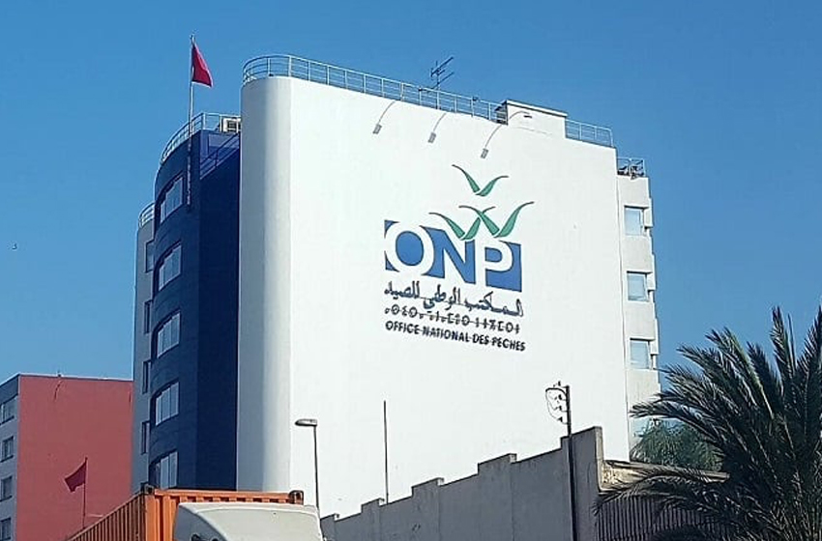Figure 1: The main building of the National Office of Fisheries
The ONP is a leading public enterprise promoting the development and competitiveness of the fisheries sector. It focuses on modernizing production, supporting artisanal fisheries, organizing seafood marketing, controlling market information, and promoting domestic fish consumption. Operating across the value chain, the ONP falls under the supervision of the Ministry of Agriculture, Maritime Fisheries, Rural Development, and Water and Forests.

2. Missions and Objectives:

2.1 Development of Coastal and Artisanal Fishing

Figure 2: Development of Coastal and Artisanal Fishing
The ONP’s main mission is to develop and modernize coastal and artisanal fishing. Its goals include promoting an integrated industry policy, supporting and restructuring the sector, upgrading the fishing fleet, organizing seafood marketing, and ensuring sustainable management of resources.

2.2. Organization of the Marketing of Marine Fishery Products
The ONP’s core mission is to organize, manage, and modernize the marketing of marine fishery products. It aims to preserve product quality, ensure better value for fishery products in wholesale markets, maximize efficiency and transparency of transactions, strengthen and upgrade distribution channels, and maintain a balance between supply and demand. In addition, the ONP oversees wholesale market management, approves industrial fish products, controls commercial information, modernizes handling methods, and promotes domestic fish consumption.
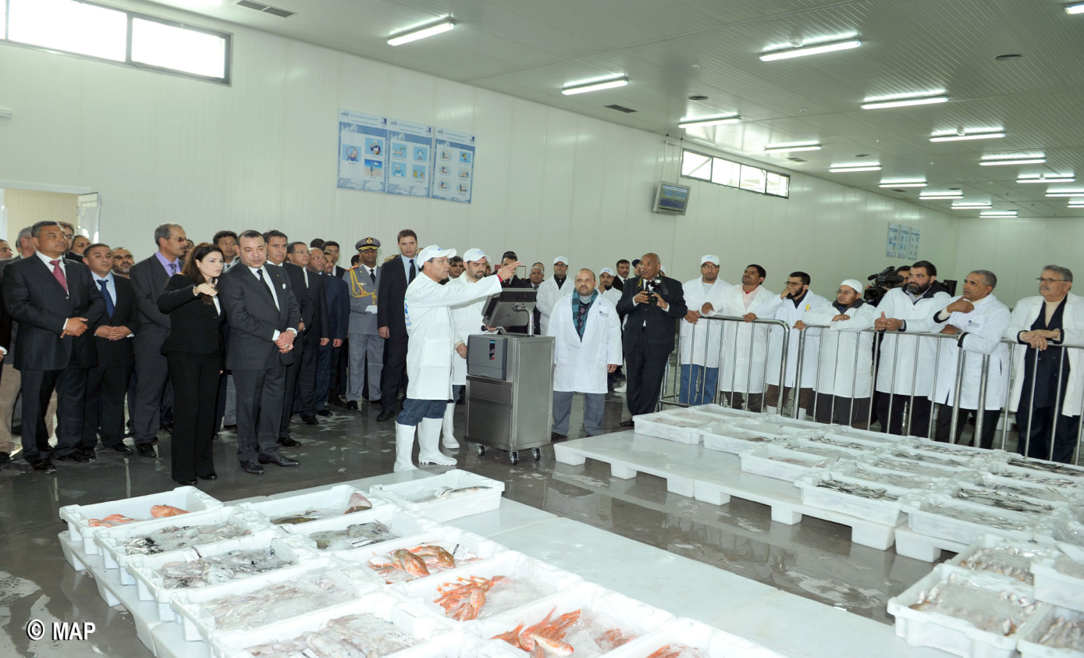
Figure 3:Organization of the Marketing of Marine Fishery Products

3. Internal Organization (Organizational Chart):
The ONP is structured into several divisions and specialized departments to ensure coordination and effective management.
General Management: Oversees strategic decisions, coordination, internal audits, compliance, and project implementation.
Support Division: Handles human resources, finance, procurement, logistics, and IT systems.
Development Division: Focuses on quality, safety, environmental compliance, strategy, partnerships, and infrastructure maintenance.
Operations Division: Manages the first and second sales of fishery products and supervises 9 regional departments to ensure local adaptation.

4. Organizational Chart:
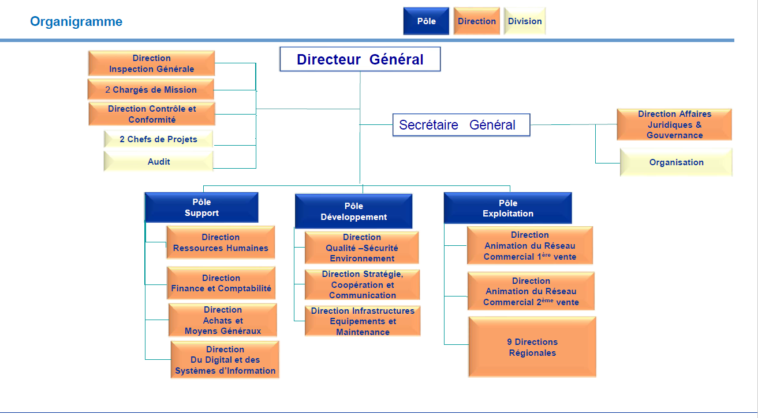
Figure 4: ONP Organizational Structure

5. Conclusion :
The ONP ensures the development, modernization, and sustainable management of Morocco’s fisheries sector. Through its structured divisions, it coordinates activities from production to marketing, enhancing efficiency, competitiveness, and value creation in the industry.

Chapter 2 :

«Context and Objectives of the Project»

Introduction :
During my internship, I needed to define the context in which my project fits, as well as its objectives. Understanding the reasons behind the work, the problems to solve, and the goals to achieve is an essential step before moving on to the technical part. This chapter presents the context of the project, the problem statement, and the objectives that guided my work.

1. Project Context :
In a context where information system security is a major concern for organizations, it is essential to implement effective protection mechanisms to ensure the confidentiality, integrity, and availability of data. The Office National des Pêches (ONP), as an institution managing strategic information, places particular emphasis on securing its network infrastructure. To illustrate and better understand these mechanisms, a virtual laboratory was designed. This environment makes it possible to simulate real conditions where critical services and protection solutions such as pfSense are deployed.

2. Problem Statement :
A server connected to a network usually offers several services to users, such as SSH for remote administration or HTTP for web applications. However, each open service represents a potential entry point for attackers. The greater the number of exposed services, the larger the attack surface, and the higher the risk of intrusion.
In many real-world environments, services may remain enabled even when they are not strictly required. Without proper firewall rules, these services can be exploited by malicious actors. Hence, the problem addressed in this project can be stated as follows:
How can the attack surface of a server be reduced by restricting access to unnecessary services through firewall configuration?

3. Project Objectives :

General Objective:
To design and implement a virtual laboratory that demonstrates the process of auditing and securing a local area network.

Specific Objectives:
- Create a virtual environment using Oracle VirtualBox.
- Install and configure pfSense as a firewall and network gateway.
- Deploy an Ubuntu server as a target machine, running essential services such as SSH and Apache.
- Use Kali Linux as the auditing workstation to perform security scans.
- Conduct an initial Nmap scan to identify exposed ports and services on the Ubuntu server.
- Define and apply firewall rules on pfSense to block or filter unnecessary services.
- Perform a second scan to evaluate the impact of these rules.
- Compare the results before and after firewall configuration.
- Provide recommendations for strengthening network security in professional environments.

4. Presentation of the Tools :


4.1 pfSense CE (Community Edition):
pfSense is an open-source firewall and router based on FreeBSD, offering stateful packet filtering, NAT, DHCP, VPN, traffic shaping, and logging. Its web-based GUI simplifies configuration while supporting advanced features like high availability, multi-WAN, and additional packages.


4.2 Kali Linux 2025.x:
Kali Linux is a Debian-based distribution designed for security testing and digital forensics. It includes a wide range of tools for scanning, vulnerability assessment, exploitation, and network analysis, making it a common choice for security professionals in controlled testing environments.


4.3 Ubuntu Server 22.04 LTS:
Ubuntu Server is a stable and secure Linux distribution maintained by Canonical, widely used for hosting services and applications. It supports web servers, databases, SSH, and containers, offers strong community and commercial support, regular security updates, and allows efficient service management via the command line and systemd.


4.4 Nmap :
Nmap (Network Mapper) is an open-source tool for network discovery and security auditing. It supports multiple scanning techniques (TCP SYN scan, TCP connect, UDP scan), service and version detection, OS fingerprinting, and scriptable interaction through the Nmap Scripting Engine (NSE). Nmap produces structured outputs that can be saved in text, XML, or grepable formats, facilitating automated analysis and documentation of network security assessments.


4.5 Packet Tracer 8.x:
Packet Tracer is a Network simulation tool from Cisco used to design and visualize the network topology. Packet Tracer allowed the creation of diagrams showing VM connections, IP addressing, and interface configuration, making it easier to plan the virtual lab setup before implementing it in VirtualBox.

Conclusion :
In conclusion, this chapter outlined the main motivations for carrying out the project and clearly defined the objectives to achieve. By identifying the risks linked to exposed network services, I was able to set precise goals, such as reducing the attack surface through firewall rules. These elements provided the foundation for the methodology and implementation that will be described in the following chapters.

Chapter 3:

«Technical Environment and Methodology»

Introduction :
This chapter presents the technical environment in which the project was conducted as well as the methodology followed. It describes the hardware and software resources used to build the virtual laboratory and explains the network topology designed. Finally, it outlines the different methodological steps adopted to achieve the project objectives.

1. Hardware Environment :
the project was implemented on a personal computer equipped with the following specifications:
- Processor: Intel Core i5 (6th generation) at 2.5 GHz, ensuring stable performance for running multiple virtual machines.
- Memory (RAM): 8 GB of RAM, sufficient to allocate resources to pfSense, Ubuntu, and Kali Linux while maintaining smooth operation.
- Storage: A 256 GB SSD with at least 40 GB free, used for system installation, log storage, and experiment data. The SSD provides faster access and better responsiveness than traditional hard drives.
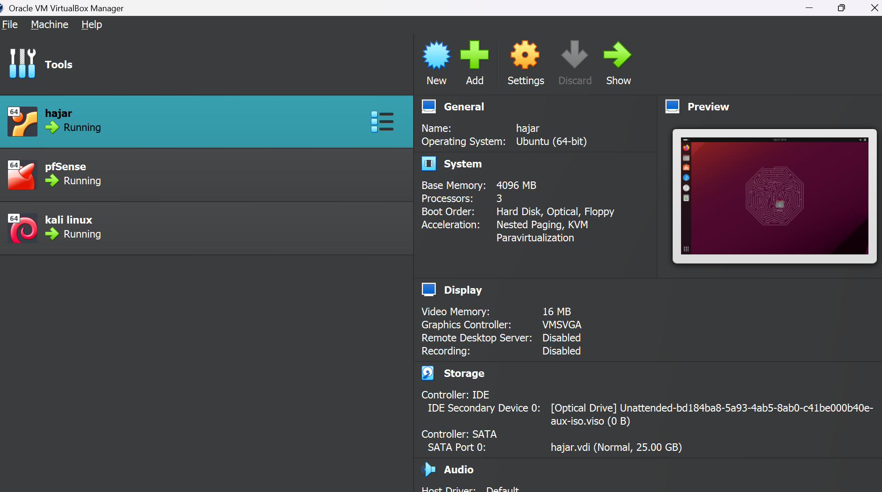
Figure 5: VirtualBox main dashboard showing the three created VMs

2. Software Environment :
The laboratory was built using virtualization technology, with three virtual machines:

2.1 pfSense CE (Community Edition):
This open-source firewall and router was deployed to control the network traffic between the internal network and the external world. pfSense provides advanced firewall features, NAT capabilities, and routing services, making it an ideal choice for a controlled virtual lab environment. Its flexibility also allowed the creation of rules to simulate real-world security policies. [1]

2.2 Kali Linux 2025.x:
Kali Linux, a specialized penetration testing distribution, was used as the attacker machine. It comes preloaded with tools for scanning, vulnerability assessment, and exploitation. In this lab, Kali served as the testing platform to evaluate the security of the Ubuntu server and the effectiveness of pfSense firewall rules. [3]

2.3 Ubuntu Server 22.04 LTS:
This machine acted as the target server, hosting essential services such as SSH and Apache web server. Ubuntu Server was selected due to its stability, widespread use in enterprise environments, and strong community support, which simplifies the deployment of services and configurations. [2]

3. Network Topology :
The virtual network was designed to emulate a small-scale enterprise environment with two main interfaces on pfSense:
- WAN Interface: Connected to the NAT network, this interface simulated the external network and allowed the virtual machines to access the internet if needed.
- LAN Interface: Connected to an Internal Network within VirtualBox, this interface linked pfSense, Kali Linux, and Ubuntu Server. The internal network provided a secure environment for testing without exposing the VMs to the host network.
The addressing plan was carefully defined to ensure clear communication between machines:

Device | IP Address | Role
pfSense LAN | 192.168.10.1 | Gateway/firewall for internal network
Ubuntu Server | 192.168.10.30 | Target machine hosting services
Kali Linux | 192.168.10.20 | Attacker machine for penetration tests
- network devices and Roles table

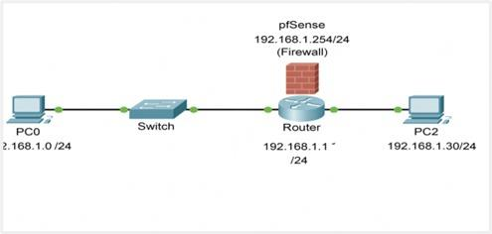
Figure 6: Network Topology Diagram created in Packet Tracer

This topology allowed controlled experimentation, making it possible to test firewall rules and network configurations in a realistic environment.

4. Methodology :
The implementation of the virtual laboratory followed a structured methodology to ensure a systematic and repeatable process:
- Installation of Virtual Machines:The first step involved installing pfSense, Ubuntu Server, and Kali Linux in VirtualBox, ensuring that each OS was properly set up and updated.
- Configuration of Network Interfaces:Network adapters for each VM were configured according to the addressing plan. pfSense was set as the default gateway for Ubuntu and Kali to enable traffic routing and firewall management.
- Deployment of Services on Ubuntu:Essential services such as SSH for remote access and Apache for web hosting were installed on the Ubuntu server. This step created the targets for penetration testing.
- Initial Scanning with Nmap:Kali Linux was used to perform initial scans using Nmap. This provided an overview of the open ports and running services on the Ubuntu server before applying any firewall restrictions.
- Application of Firewall Rules on pfSense:Custom firewall rules were implemented on pfSense to restrict access to the Ubuntu server based on source IP and service type. This simulated real-world network security policies. [7]
- Verification with a Second Nmap Scan:A follow-up scan was conducted from Kali Linux to verify the effectiveness of the firewall rules, confirming that unauthorized access was successfully blocked while authorized traffic remained functional. [8]

Conclusion :
This chapter presented the technical environment of the project, including the software and hardware resources used to build the virtual laboratory. The network topology was designed and visualized with Packet Tracer, and the methodology for implementing and testing the network was outlined. These preparations provide a clear foundation for the practical steps and results, which will be detailed in the next chapter.

Chapter 4:

«Implementation of the project»

Introduction :
This chapter presents the practical realization of the project. It details the installation of the virtual machines, the configuration of the networkenvironment, the deployment of services on the server, and the security auditing process.

1. Installation of Virtual Machines :

pfSense Installation:
pfSense was installed as the firewall and gateway of the virtual laboratory. During installation, default options were chosen to simplify the setup. Two network interfaces were configured:
AN connected to NAT: NAT was chosen so that the virtual machines can access the internet when needed (for updates, downloading tools, etc.) without exposing the internal lab directly to the physical network of the host computer. This ensures both connectivity and isolation.
LAN connected to the Internal Network: The LAN was created as a private environment where the Ubuntu server and Kali Linux could communicate safely. All the traffic between these machines passes through pfSense, which makes it possible to control and filter the exchanges, just like in a professional network.

Ubuntu Server Installation:
Ubuntu Server was deployed as the target machine of the environment. A static IP address (192.168.1.30) was assigned to ensure stable connectivity. This machine was prepared to host the services required for the project, such as SSH and Apache.

Kali Linux Installation:
kali Linux was installed as the auditing machine. It was connected to the same internal network as Ubuntu to be able to scan it and test its security. The reason for using Kali is that it contains professional auditing tools like Nmap that are commonly used in penetration testing.

Network Configuration:
the following addressing plan was applied:
pfSense LAN → 192.168.10.1
Ubuntu Server → 192.168.1.30
Kali Linux → 192.168.10.20
The reason for this configuration is to keep a simple and clear structure where pfSense acts as the gateway and both client machines are inside the same subnet. Connectivity was tested using the ping command to confirm that each machine could reach the others.

Deployment of Services on Ubuntu:
SSH Service:
oPenSSH was installed and activated. enabling SSH is to allow secure remote access to the server, which simulates how administrators usually manage servers in professional environments.
Apache Web Server:
apache2 was installed to simulate a web application hosted on the server. This service was chosen because HTTP servers are one of the most common services exposed to the internet and therefore represent a typical attack target.

Security Audit:

Initial Scan (Before Firewall Rules):
Before configuring the firewall, an Nmap scan was performed from the Kali Linux machine targeting the Ubuntu server to identify open ports and running services. This helps in detecting potential vulnerabilities. [4]

Command used:
Nmap-sS-Pn-p-192.168.1.30-oN~/before_scan_192.168.1.30.txt
-sS → Performs a TCP SYN scan (stealth scan).
-Pn → Treats the host as online without pinging.
-p- → Scans all 65535 TCP ports.
-oN → Saves the output to a text file for documentation.
Result:
The scan showed that ports 22 (SSH) and 80 (HTTP) were open. These services could be exploited if left unprotected.

Firewall Configuration on pfSense:
To secure the server, firewall rules were configured on pfSense to allow only necessary traffic while blocking everything else.
Steps and rules applied:
- Access pfSense interface → https://192.168.1.1
- Navigate to Firewall → Rules → LAN/WAN.
- Create rules:
- Allow TCP port 22 from specific trusted IPs (SSH).
- Allow TCP port 80 from any (HTTP).
- Block all other traffic by default.
These rules reduce the risk of intrusion and provide controlled access to critical services.
Final Scan (After Firewall Rules):
After applying the firewall rules, a second Nmap scan was executed to verify the configuration.
Command used:
nmap-sS-Pn-p-192.168.1.30-oN~/after_scan_192.168.1.30.txt

Result:
The scan confirmed that all unnecessary ports were blocked, and only ports 22 (SSH) and 80 (HTTP) remained accessible. This verified that the firewall configuration was effective.

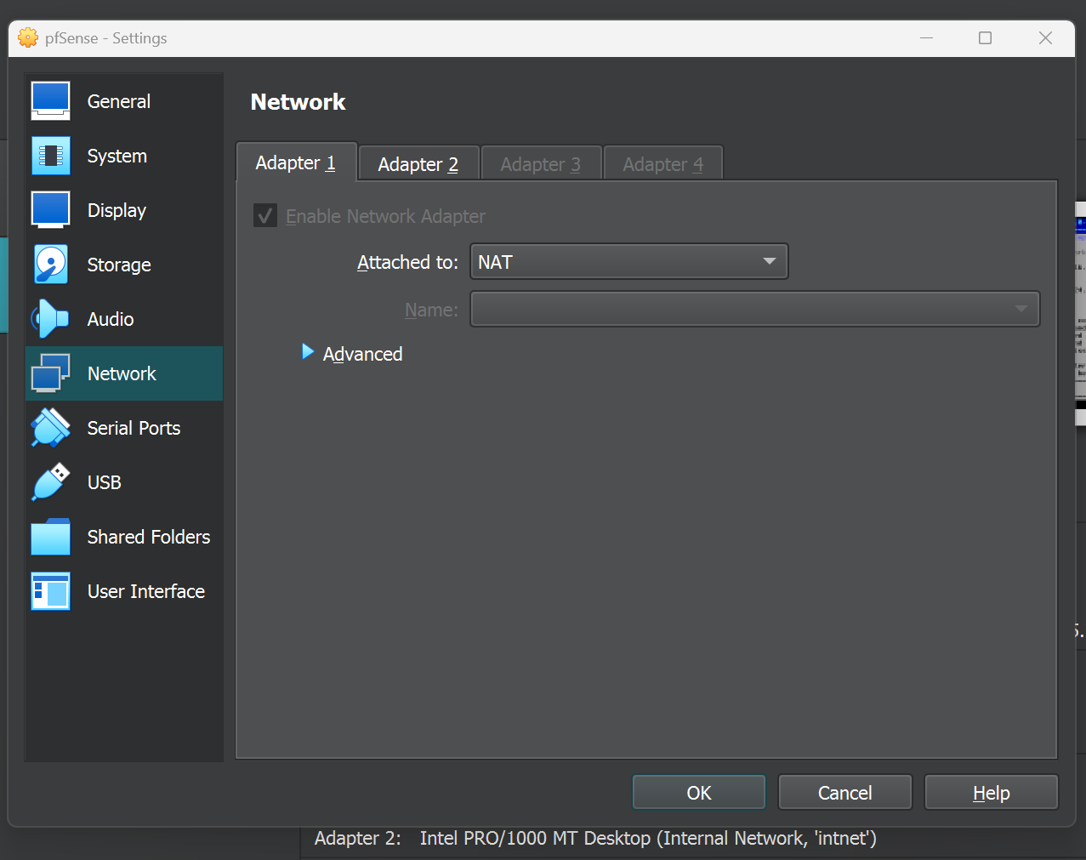
2. Illustrations of the Implementation :
Figure 7: pfSense WAN interface configuration

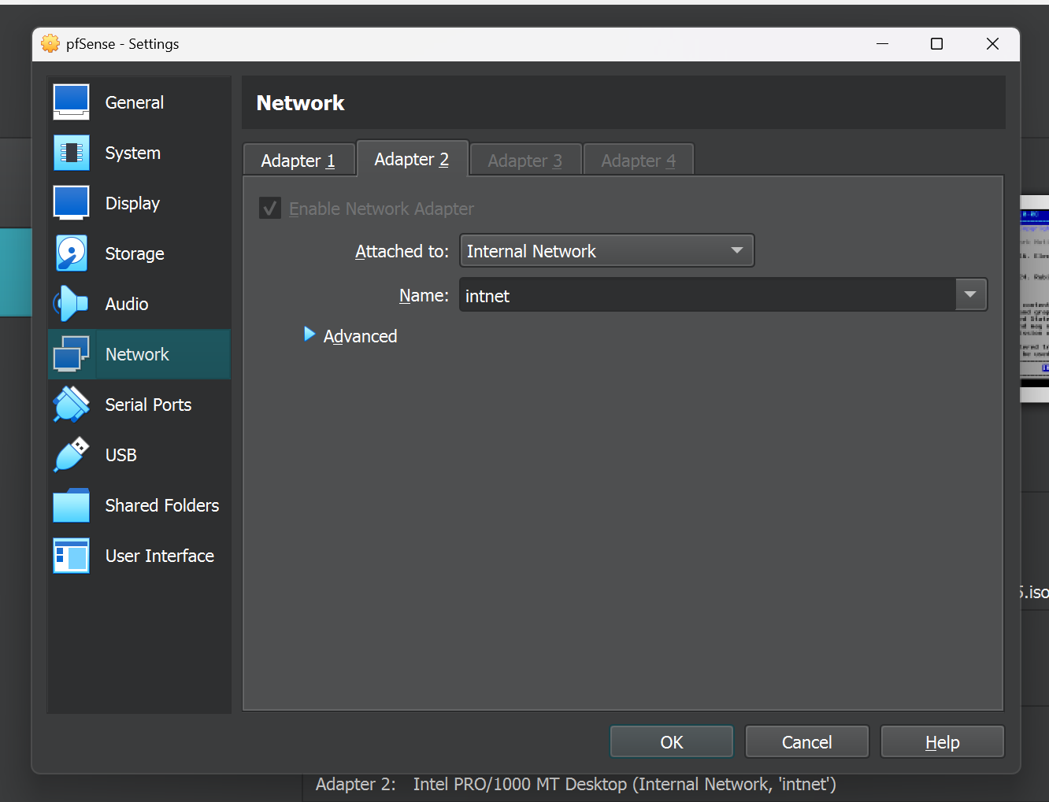
Figure 8: pfSense LAN interface configuration
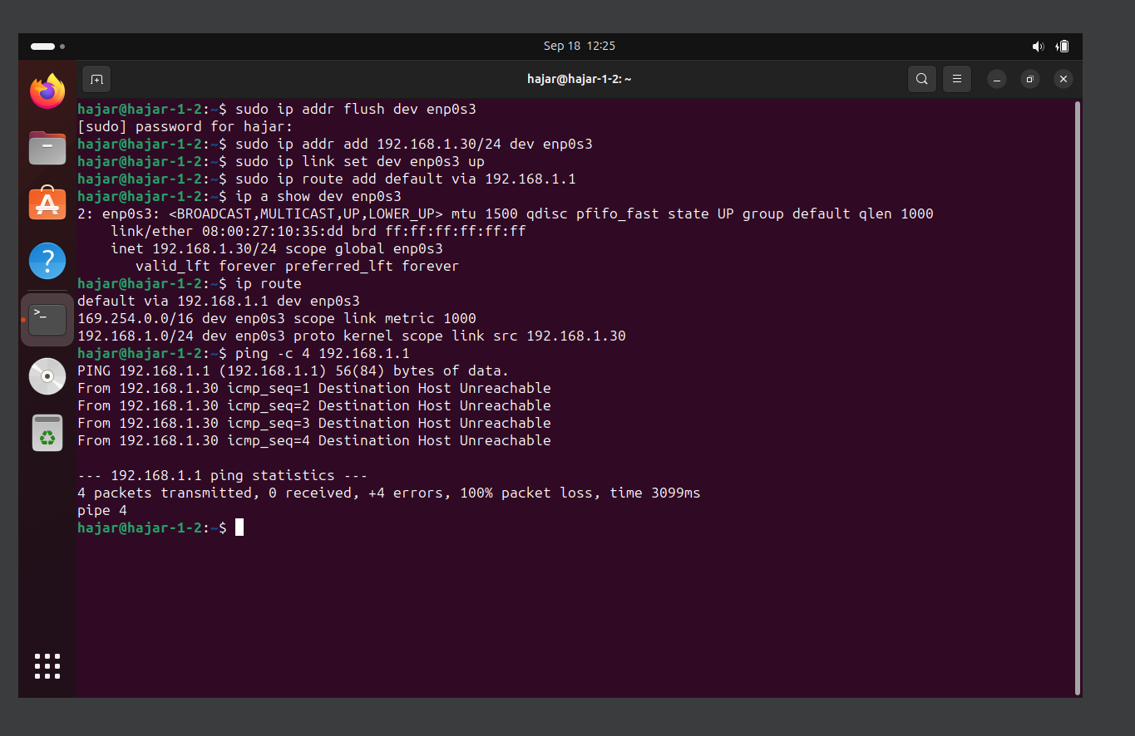Figure 9: Ubuntu terminal showing static IP address
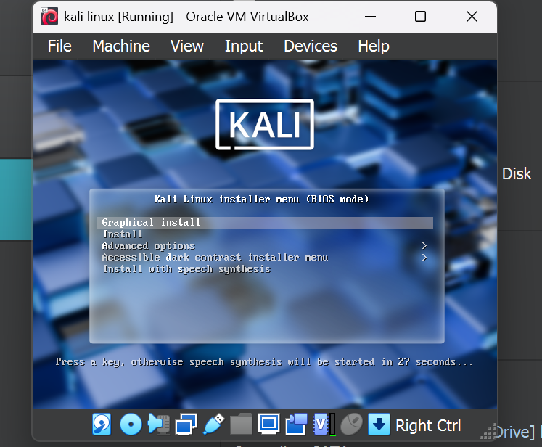
Figure 10: Installation process of Kali Linux
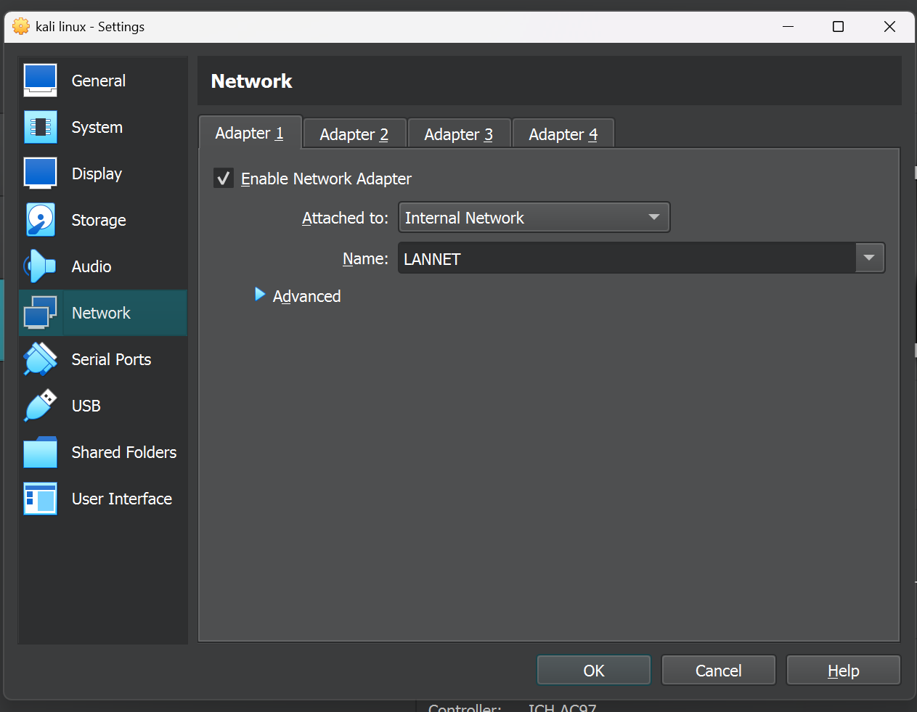
Figure 11: Network adapter settings of Kali Linux
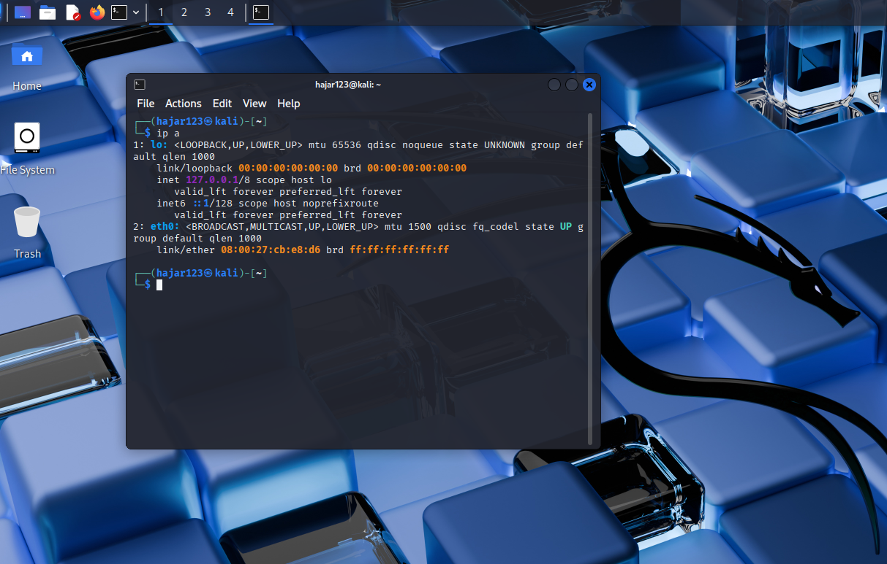
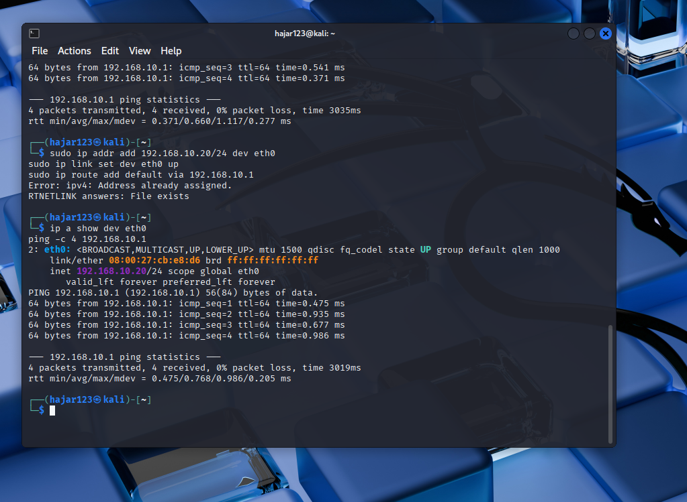
Figure 12: Ubuntu terminal showing static IP address
Figure 13: Connectivity test from Kali Linux to Ubuntu server
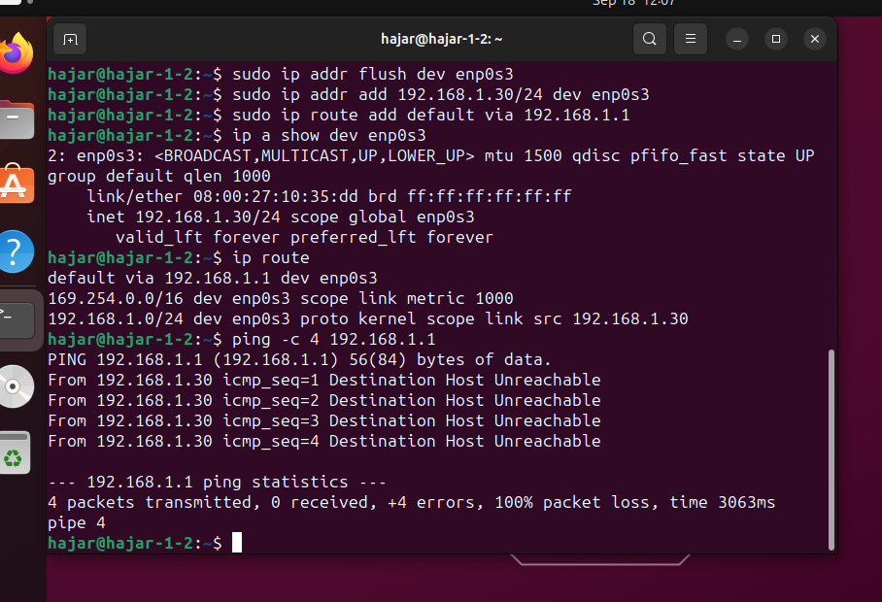
Figure 14: Connectivity test from Ubuntu server to pfSense
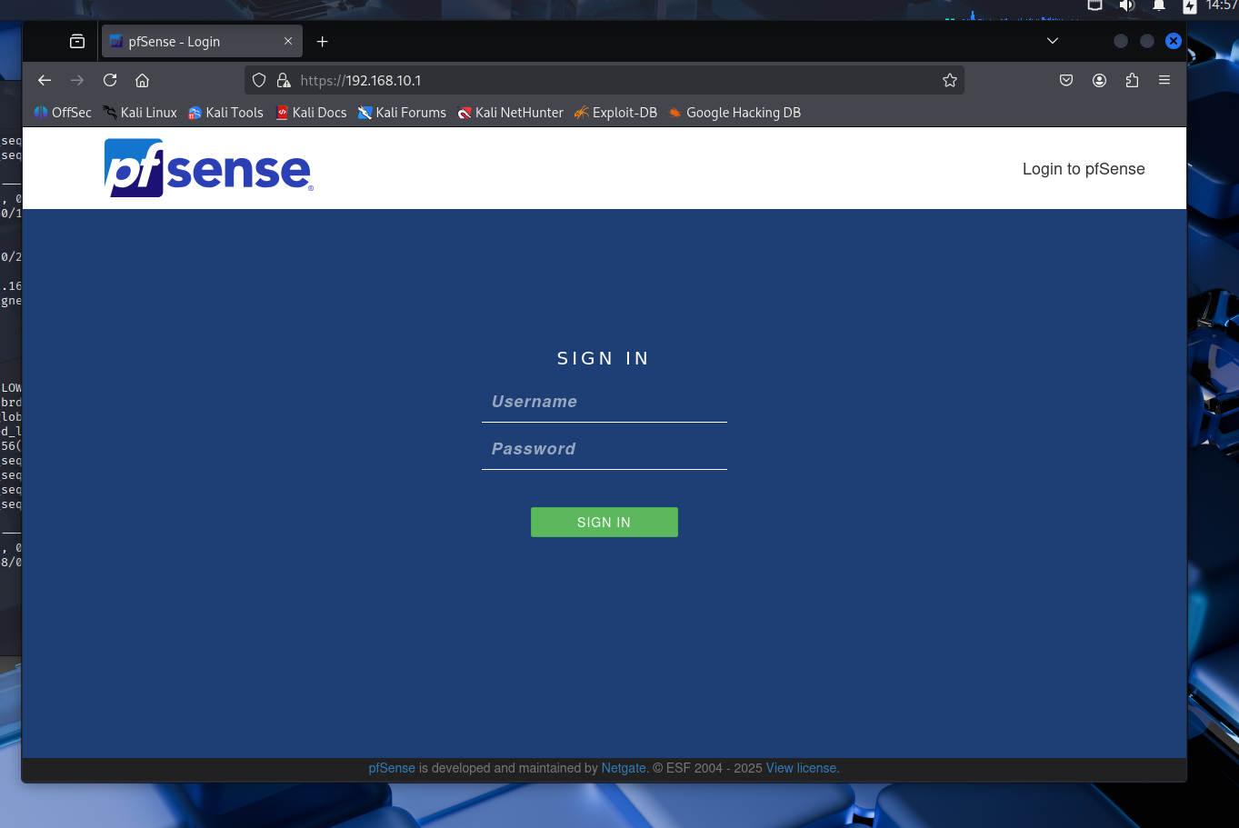Figure 15: pfSense login page accessed from Kali browser
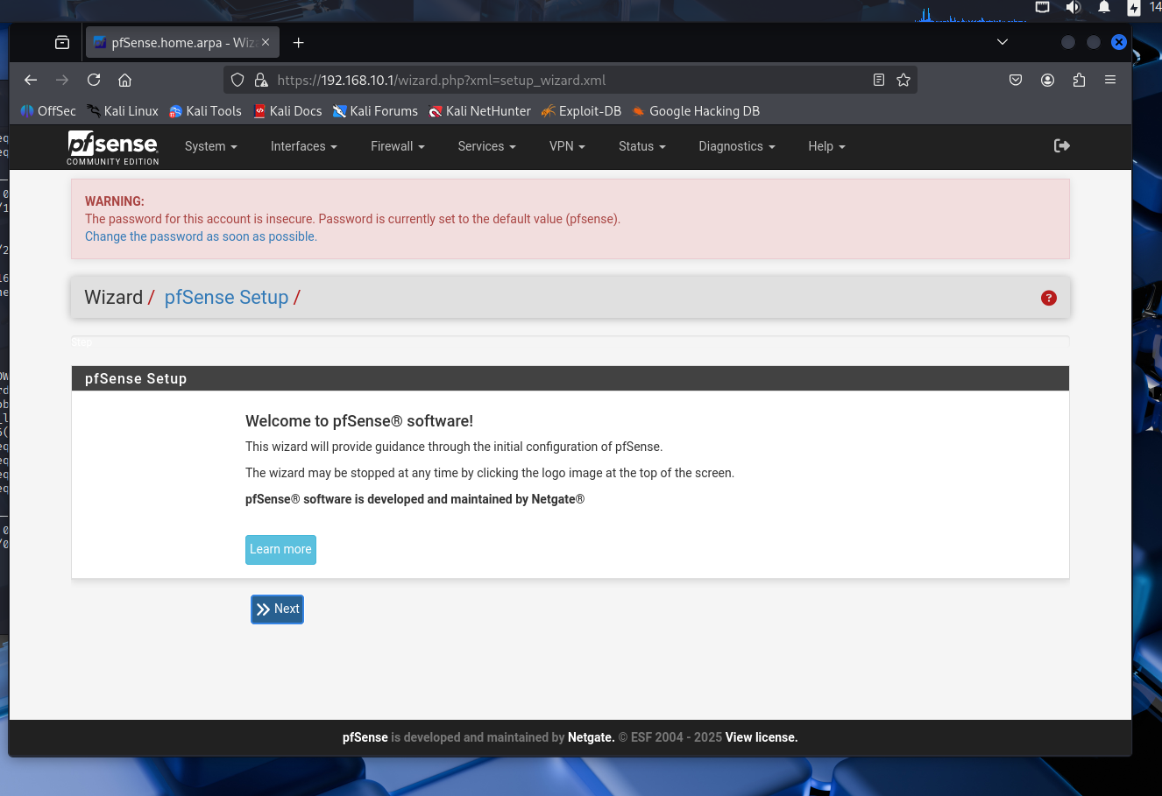
Figure 16:pfSense web interface welcome dashboard
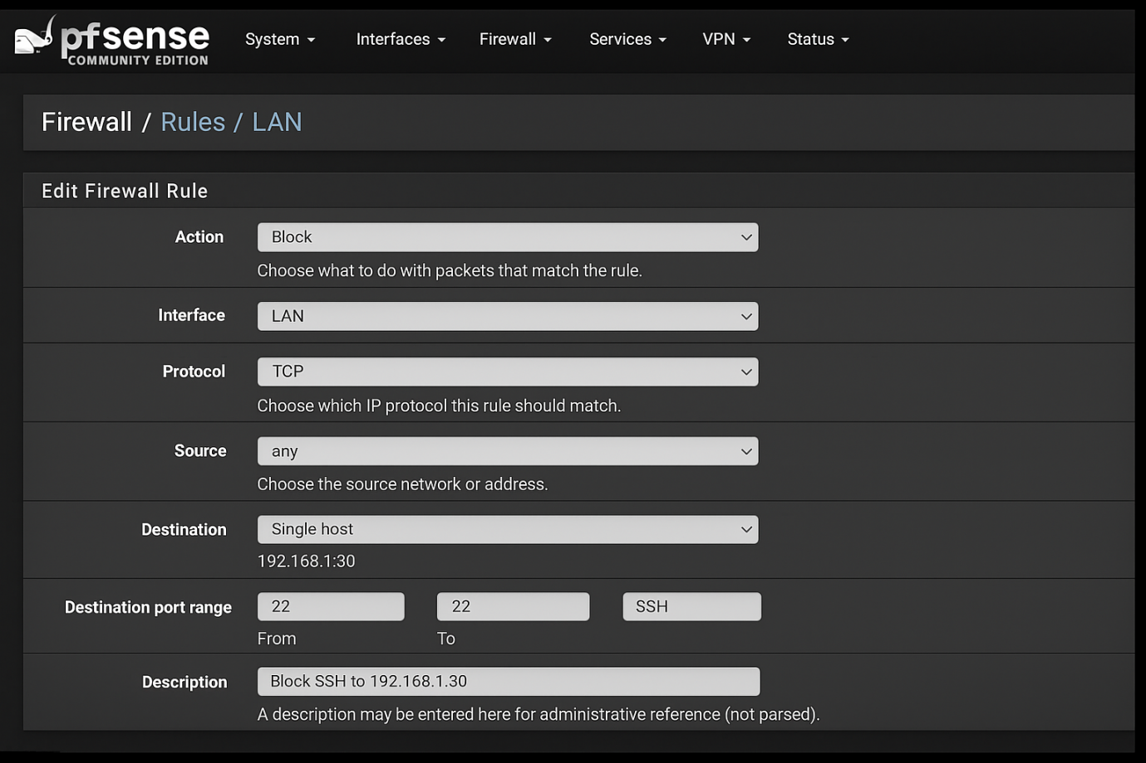
Figure 18: pfSense firewall rules configuration (web GUI)

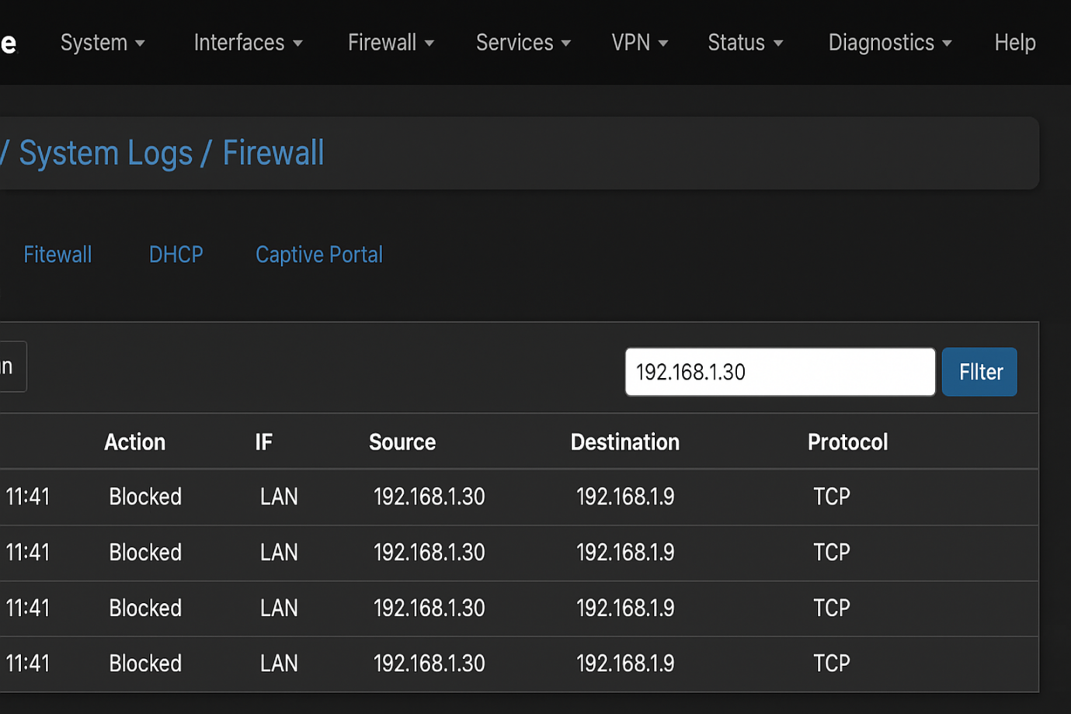
Figure 20: Firewall logs in pfSense showing blocked traffic from the Ubuntu server

Chapter 5:

«Results and Analysis»

Introduction :
This chapter analyzes the results obtained during the security audit. It compares the scans executed before and after applying firewall rules and highlights the impact of filtering policies on network security.

Scan Results Comparison:
The initial scan from Kali revealed multiple open ports on the Ubuntu server, including SSH (22) and HTTP (80). After firewall rules were applied, the final scan displayed a reduced number of open ports, showing that the filtering was effective.

State | Open Ports | Services
Before firewall | 22, 80 | SSH, Apache HTTP
After firewall | 22 (restricted) | SSH only
Table 2 — Firewall Configuration Results

Interpretation of Results:

The comparison demonstrates that:
- The firewall significantly reduced the server’s exposure.
- Only necessary services remained available.
- The overall attack surface of the network decreased.
This validates the importance of access control rules in securing IT infrastructures.

Discussion and Limitations:
While the lab confirmed the efficiency of firewall rules, it remained a simplified environment. More advanced measures such as IDS/IPS, VPN tunnels, and monitoring dashboards could further strengthen security. Additionally, the use of a single server limited the scope of testing to basic services.

Lessons Learned:
Several key lessons emerged from this project:
- Correct network design is essential for proper communication between systems.
- Even simple firewall rules can have a strong impact on security.
- Practical troubleshooting skills are critical when dealing with configuration issues.

Conclusion:
The results analysis showed a clear reduction of vulnerabilities after applying firewall rules. Despite limitations, the project successfully demonstrated the role of firewalls in protecting networks and highlighted valuable skills for real-world applications.

General Conclusion

This internship project allowed me to design and implement a virtual laboratory dedicated to the audit and security of a local area network. Using VirtualBox, pfSense, Ubuntu, and Kali Linux, I successfully simulated a realistic environment in which network services were deployed, tested, and secured. The application of firewall rules on pfSense clearly demonstrated the importance of access control mechanisms in reducing vulnerabilities and protecting systems from potential attacks.
Beyond the technical achievements, this project strengthened my ability to solve problems, adapt configurations, and apply theoretical knowledge in a practical context. It highlighted the relevance of virtualization for learning network security and showed how even simple architectures can provide valuable insights into system protection.
In conclusion, this work offered me not only technical skills but also professional maturity, and it laid a strong foundation for more advanced studies and projects in cybersecurity and network administration.

Web References

[1]pfSense Official Documentation : https://docs.netgate.com/pfsense/en/latest/
[2]Ubuntu Server Documentation : https://ubuntu.com/server/docs
[3]Kali Linux Documentation : https://www.kali.org/docs/
[4]Nmap Network Scanning Guide : https://nmap.org/book/
[5]Oracle VirtualBox Documentation : https://www.virtualbox.org/manual/
[6]How-To Geek – Networking Guides : https://www.howtogeek.com/
[7]Network Security using pfSense (Tutorial Video) – NetworkChuck Channel : https://www.youtube.com/@NetworkChuck
[8]Nmap Tutorial for Beginners – TechHut Channel : https://www.youtube.com/@TechHut

